MACHINE LEARNING LAB – OBSERVATION RECORD
EXPERIMENT 1: FIND-S ALGORITHM
Experiment No.: 1
Date: _14/10/2026___________________
Experiment Question: Implement and demonstrate the FIND-S algorithm for finding the most specific hypothesis based on a given set of training data samples.

FIND-S: General concept and mathematical rule
FIND-S is a concept-learning algorithm. It begins with the most specific hypothesis and processes only positive training examples. For each attribute, it keeps the value if all positive examples seen so far agree; otherwise, it replaces the attribute with “?”. The symbol “?” means any value is accepted. The symbol “Ø” below represents an attribute that has not yet been assigned.
Hypothesis representation: H = (h₁, h₂, …, hₙ)
For a positive example x = (x₁, x₂, …, xₙ), update each attribute as:
hᵢ(new) = xᵢ, if hᵢ = Ø; hᵢ(new) = hᵢ, if hᵢ = xᵢ; hᵢ(new) = ?, if hᵢ ≠ xᵢ.
Negative examples are ignored. FIND-S does not use negative examples to specialize its hypothesis.
Important: the final hypothesis summarizes these training examples; it does not prove a real-world cause-and-effect relationship.

Subproblem 1: Enjoy Sport Prediction

1. Aim
To implement FIND-S and learn the most specific hypothesis for predicting whether a person enjoys a sport from weather conditions.

2. Concept
The attributes are Sky, Temperature, Humidity, and Wind. The target is Enjoy Sport. Only rows labelled Yes are used to update the hypothesis.

3. Dataset Description
The training examples are shown below. The last column is the target class.
Sky | Temperature | Humidity | Wind | Enjoy Sport
Sunny | Warm | Normal | Strong | Yes
Sunny | Warm | High | Strong | Yes
Rainy | Cold | High | Strong | No
Sunny | Warm | High | Weak | Yes

4. Algorithm
- Initialize H to the most specific hypothesis (Ø in every attribute).
- Read each training example from left to right.
- If the target is No, ignore the example.
- If the target is Yes, compare each attribute with H.
- Replace Ø with the example value; if a value conflicts with the current specific value, replace it with ?; otherwise keep it unchanged.
- Display the final hypothesis after all examples have been processed.

5. Step-by-step Procedure and Detailed Calculations
- Start: H₀ = (Ø, Ø, Ø, Ø).
- Example 1 is positive: (Sunny, Warm, Normal, Strong). Replace each Ø with the corresponding value. H₁ = (Sunny, Warm, Normal, Strong).
- Example 2 is positive: (Sunny, Warm, High, Strong). Sky, Temperature, and Wind match. Humidity differs (Normal ≠ High), so generalize that attribute. H₂ = (Sunny, Warm, ?, Strong).
- Example 3 is negative (No), so FIND-S ignores it. H₃ = (Sunny, Warm, ?, Strong).
- Example 4 is positive: (Sunny, Warm, High, Weak). Sky and Temperature match; Humidity is already ?; Wind differs (Strong ≠ Weak), so generalize Wind. H₄ = (Sunny, Warm, ?, ?).

6. Formulae
Let H = (h₁, h₂, …, hₙ) be the current hypothesis and x = (x₁, x₂, …, xₙ) be a positive training example.
Attribute update:
• If hᵢ = Ø, then hᵢ(new) = xᵢ.
• If hᵢ = xᵢ, then hᵢ(new) = hᵢ (no change).
• If hᵢ ≠ xᵢ and hᵢ ≠ Ø, then hᵢ(new) = ?.
Final hypothesis for this dataset: Hfinal = (Sunny, Warm, ?, ?).
No numerical arithmetic is required for FIND-S: the “calculation” is a stepwise comparison of categorical attribute values. A mismatch causes generalization to ?.

7. Python Program
data = [
['Sunny', 'Warm', 'Normal', 'Strong', 'Yes'],
['Sunny', 'Warm', 'High', 'Strong', 'Yes'],
['Rainy', 'Cold', 'High', 'Strong', 'No'],
['Sunny', 'Warm', 'High', 'Weak', 'Yes']
]
h = ['Ø'] * 4
for row in data:
if row[-1] == 'Yes':
for i in range(4):
if h[i] == 'Ø':
h[i] = row[i]
elif h[i] != row[i]:
h[i] = '?'
print("Final Hypothesis:", h)

8. Output

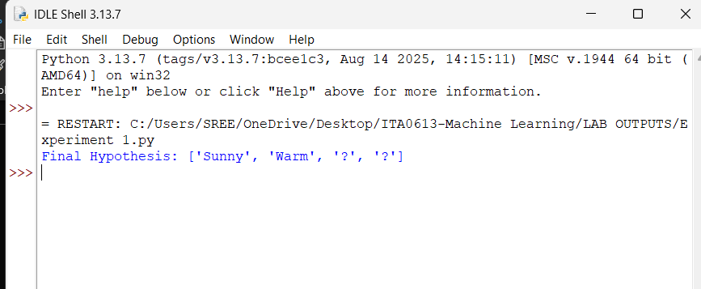9. Result / Conclusion
The FIND-S algorithm was implemented successfully for this dataset. Final hypothesis: (Sunny, Warm, ?, ?). The learned hypothesis requires Sky = Sunny and Temperature = Warm; any Humidity and Wind values are allowed by this hypothesis.
Subproblem 2: Weather Suitability Prediction

1. Aim
To apply FIND-S to learn the common conditions in examples labelled Suitable Weather = Yes.

2. Concept
The attributes are Sky, Temperature, Humidity, and Wind. The positive examples are used to generalize the hypothesis; the negative example is ignored.

3. Dataset Description
The training examples are shown below. The last column is the target class.
Sky | Temperature | Humidity | Wind | Suitable Weather
Sunny | Hot | High | Weak | Yes
Sunny | Hot | High | Strong | Yes
Rainy | Cold | High | Weak | No
Sunny | Mild | Normal | Weak | Yes

4. Algorithm
- Initialize H to the most specific hypothesis (Ø in every attribute).
- Read each training example from left to right.
- If the target is No, ignore the example.
- If the target is Yes, compare each attribute with H.
- Replace Ø with the example value; if a value conflicts with the current specific value, replace it with ?; otherwise keep it unchanged.
- Display the final hypothesis after all examples have been processed.

5. Step-by-step Procedure and Detailed Calculations
- Start: H₀ = (Ø, Ø, Ø, Ø).
- Example 1 is positive: (Sunny, Hot, High, Weak). H₁ = (Sunny, Hot, High, Weak).
- Example 2 is positive: (Sunny, Hot, High, Strong). Wind differs (Weak ≠ Strong), so H₂ = (Sunny, Hot, High, ?).
- Example 3 is negative (No), so it is ignored. H₃ = (Sunny, Hot, High, ?).
- Example 4 is positive: (Sunny, Mild, Normal, Weak). Temperature differs (Hot ≠ Mild), so Temperature becomes ?. Humidity differs (High ≠ Normal), so Humidity becomes ?. Sky remains Sunny and Wind remains ?. H₄ = (Sunny, ?, ?, ?).

6. Formulae
Let H = (h₁, h₂, …, hₙ) be the current hypothesis and x = (x₁, x₂, …, xₙ) be a positive training example.
Attribute update:
• If hᵢ = Ø, then hᵢ(new) = xᵢ.
• If hᵢ = xᵢ, then hᵢ(new) = hᵢ (no change).
• If hᵢ ≠ xᵢ and hᵢ ≠ Ø, then hᵢ(new) = ?.
Final hypothesis for this dataset: Hfinal = (Sunny, ?, ?, ?).
No numerical arithmetic is required for FIND-S: the “calculation” is a stepwise comparison of categorical attribute values. A mismatch causes generalization to ?.

7. Python Program
data = [
['Sunny', 'Hot', 'High', 'Weak', 'Yes'],
['Sunny', 'Hot', 'High', 'Strong', 'Yes'],
['Rainy', 'Cold', 'High', 'Weak', 'No'],
['Sunny', 'Mild', 'Normal', 'Weak', 'Yes']
]
h = ['Ø'] * 4
for row in data:
if row[-1] == 'Yes':
for i in range(4):
if h[i] == 'Ø':
h[i] = row[i]
elif h[i] != row[i]:
h[i] = '?'
print("Final Hypothesis:", h)

8. Output

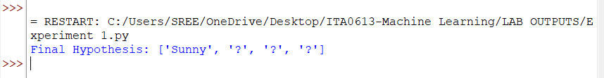9. Result / Conclusion
The FIND-S algorithm was implemented successfully for this dataset. Final hypothesis: (Sunny, ?, ?, ?). Among the positive examples, Sky remains Sunny while Temperature, Humidity, and Wind vary.

Subproblem 3: Student Performance Prediction

1. Aim
To use FIND-S to identify the attribute pattern shared by students whose result is Pass.

2. Concept
The attributes are Attendance, Internal Marks, and Assignment Submission. The target is Result. In the program, Yes represents Pass and No represents Fail.

3. Dataset Description
The training examples are shown below. The last column is the target class.
Attendance | Internal Marks | Assignment | Result
High | Good | Regular | Yes
High | Good | Irregular | Yes
Low | Poor | Regular | No
Medium | Good | Regular | Yes

4. Algorithm
- Initialize H to the most specific hypothesis (Ø in every attribute).
- Read each training example from left to right.
- If the target is No, ignore the example.
- If the target is Yes, compare each attribute with H.
- Replace Ø with the example value; if a value conflicts with the current specific value, replace it with ?; otherwise keep it unchanged.
- Display the final hypothesis after all examples have been processed.

5. Step-by-step Procedure and Detailed Calculations
- Start: H₀ = (Ø, Ø, Ø).
- Example 1 is positive: (High, Good, Regular). H₁ = (High, Good, Regular).
- Example 2 is positive: (High, Good, Irregular). Assignment differs (Regular ≠ Irregular), so H₂ = (High, Good, ?).
- Example 3 is negative (No), so it is ignored. H₃ = (High, Good, ?).
- Example 4 is positive: (Medium, Good, Regular). Attendance differs (High ≠ Medium), so Attendance becomes ?. Internal Marks remains Good and Assignment is already ?. H₄ = (?, Good, ?).

6. Formulae
Let H = (h₁, h₂, …, hₙ) be the current hypothesis and x = (x₁, x₂, …, xₙ) be a positive training example.
Attribute update:
• If hᵢ = Ø, then hᵢ(new) = xᵢ.
• If hᵢ = xᵢ, then hᵢ(new) = hᵢ (no change).
• If hᵢ ≠ xᵢ and hᵢ ≠ Ø, then hᵢ(new) = ?.
Final hypothesis for this dataset: Hfinal = (?, Good, ?).
No numerical arithmetic is required for FIND-S: the “calculation” is a stepwise comparison of categorical attribute values. A mismatch causes generalization to ?.

7. Python Program
data = [
['High', 'Good', 'Regular', 'Yes'],
['High', 'Good', 'Irregular', 'Yes'],
['Low', 'Poor', 'Regular', 'No'],
['Medium', 'Good', 'Regular', 'Yes']
]
h = ['Ø'] * 3
for row in data:
if row[-1] == 'Yes':
for i in range(3):
if h[i] == 'Ø':
h[i] = row[i]
elif h[i] != row[i]:
h[i] = '?'
print("Final Hypothesis:", h)

8. Output

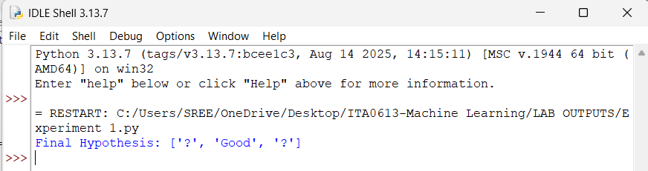9. Result / Conclusion
The FIND-S algorithm was implemented successfully for this dataset. Final hypothesis: (?, Good, ?). The positive examples share Good internal marks; attendance and assignment status vary in this small dataset.

Subproblem 4: Animal Classification

1. Aim
To implement FIND-S to learn the common attribute pattern of animals belonging to a target category.

2. Concept
The attributes are Body Temperature, Number of Legs, and Habitat. The target label is Animal Category (Yes/No).

3. Dataset Description
The training examples are shown below. The last column is the target class.
Body Temperature | Legs | Habitat | Animal Category
Warm | Four | Land | Yes
Warm | Four | Land | Yes
Cold | Two | Water | No
Warm | Four | Water | Yes

4. Algorithm
- Initialize H to the most specific hypothesis (Ø in every attribute).
- Read each training example from left to right.
- If the target is No, ignore the example.
- If the target is Yes, compare each attribute with H.
- Replace Ø with the example value; if a value conflicts with the current specific value, replace it with ?; otherwise keep it unchanged.
- Display the final hypothesis after all examples have been processed.

5. Step-by-step Procedure and Detailed Calculations
- Start: H₀ = (Ø, Ø, Ø).
- Example 1 is positive: (Warm, Four, Land). H₁ = (Warm, Four, Land).
- Example 2 is positive and identical to Example 1, so no change occurs. H₂ = (Warm, Four, Land).
- Example 3 is negative (No), so it is ignored. H₃ = (Warm, Four, Land).
- Example 4 is positive: (Warm, Four, Water). Habitat differs (Land ≠ Water), so Habitat becomes ?. H₄ = (Warm, Four, ?).

6. Formulae
Let H = (h₁, h₂, …, hₙ) be the current hypothesis and x = (x₁, x₂, …, xₙ) be a positive training example.
Attribute update:
• If hᵢ = Ø, then hᵢ(new) = xᵢ.
• If hᵢ = xᵢ, then hᵢ(new) = hᵢ (no change).
• If hᵢ ≠ xᵢ and hᵢ ≠ Ø, then hᵢ(new) = ?.
Final hypothesis for this dataset: Hfinal = (Warm, Four, ?).
No numerical arithmetic is required for FIND-S: the “calculation” is a stepwise comparison of categorical attribute values. A mismatch causes generalization to ?.

7. Python Program
data = [
['Warm', 'Four', 'Land', 'Yes'],
['Warm', 'Four', 'Land', 'Yes'],
['Cold', 'Two', 'Water', 'No'],
['Warm', 'Four', 'Water', 'Yes']
]
h = ['Ø'] * 3
for row in data:
if row[-1] == 'Yes':
for i in range(3):
if h[i] == 'Ø':
h[i] = row[i]
elif h[i] != row[i]:
h[i] = '?'
print("Final Hypothesis:", h)

8. Output

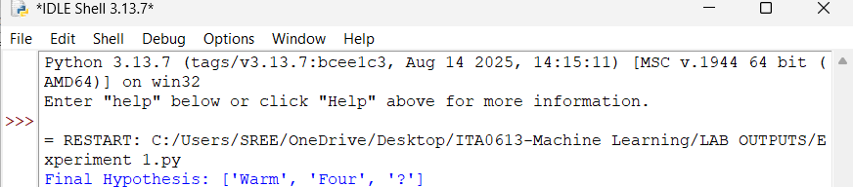9. Result / Conclusion
The FIND-S algorithm was implemented successfully for this dataset. Final hypothesis: (Warm, Four, ?). The positive examples share Warm body temperature and Four legs, while Habitat varies.

Subproblem 5: Computer Purchase Prediction

1. Aim
To apply FIND-S to learn the common attributes of computers labelled as purchased.

2. Concept
The attributes are Price, Speed, and Memory. The target is Purchase (Yes/No). Positive examples update the hypothesis.

3. Dataset Description
The training examples are shown below. The last column is the target class.
Price | Speed | Memory | Purchase
High | Fast | Large | Yes
High | Fast | Small | Yes
Low | Slow | Small | No
Medium | Fast | Large | Yes

4. Algorithm
- Initialize H to the most specific hypothesis (Ø in every attribute).
- Read each training example from left to right.
- If the target is No, ignore the example.
- If the target is Yes, compare each attribute with H.
- Replace Ø with the example value; if a value conflicts with the current specific value, replace it with ?; otherwise keep it unchanged.
- Display the final hypothesis after all examples have been processed.

5. Step-by-step Procedure and Detailed Calculations
- Start: H₀ = (Ø, Ø, Ø).
- Example 1 is positive: (High, Fast, Large). H₁ = (High, Fast, Large).
- Example 2 is positive: (High, Fast, Small). Memory differs (Large ≠ Small), so H₂ = (High, Fast, ?).
- Example 3 is negative (No), so it is ignored. H₃ = (High, Fast, ?).
- Example 4 is positive: (Medium, Fast, Large). Price differs (High ≠ Medium), so Price becomes ?. Speed remains Fast and Memory is already ?. H₄ = (?, Fast, ?).

6. Formulae
Let H = (h₁, h₂, …, hₙ) be the current hypothesis and x = (x₁, x₂, …, xₙ) be a positive training example.
Attribute update:
• If hᵢ = Ø, then hᵢ(new) = xᵢ.
• If hᵢ = xᵢ, then hᵢ(new) = hᵢ (no change).
• If hᵢ ≠ xᵢ and hᵢ ≠ Ø, then hᵢ(new) = ?.
Final hypothesis for this dataset: Hfinal = (?, Fast, ?).
No numerical arithmetic is required for FIND-S: the “calculation” is a stepwise comparison of categorical attribute values. A mismatch causes generalization to ?.

7. Python Program
data = [
['High', 'Fast', 'Large', 'Yes'],
['High', 'Fast', 'Small', 'Yes'],
['Low', 'Slow', 'Small', 'No'],
['Medium', 'Fast', 'Large', 'Yes']
]
h = ['Ø'] * 3
for row in data:
if row[-1] == 'Yes':
for i in range(3):
if h[i] == 'Ø':
h[i] = row[i]
elif h[i] != row[i]:
h[i] = '?'
print("Final Hypothesis:", h)

8. Output

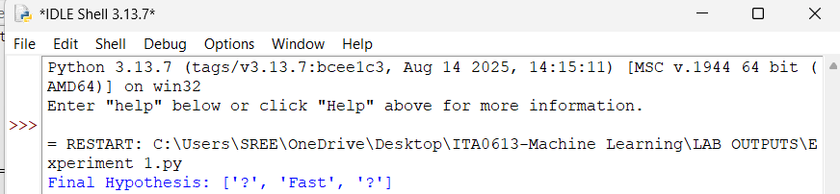9. Result / Conclusion
The FIND-S algorithm was implemented successfully for this dataset. Final hypothesis: (?, Fast, ?). The positive examples share Fast speed, while Price and Memory vary.

Overall Result of Experiment 1
FIND-S was demonstrated on five datasets. The final hypotheses are summarized below.
Subproblem | Application | Final hypothesis
1 | Enjoy Sport Prediction | (Sunny, Warm, ?, ?)
2 | Weather Suitability Prediction | (Sunny, ?, ?, ?)
3 | Student Performance Prediction | (?, Good, ?)
4 | Animal Classification | (Warm, Four, ?)
5 | Computer Purchase Prediction | (?, Fast, ?)
Final conclusion: FIND-S begins with the most specific hypothesis and generalizes only when positive examples require it. It ignores negative examples, so the learned hypothesis is not guaranteed to be the only possible concept consistent with the full dataset.
Notation: Ø = no value assigned yet; ? = any value. The exact output is based on the datasets listed in this record.

